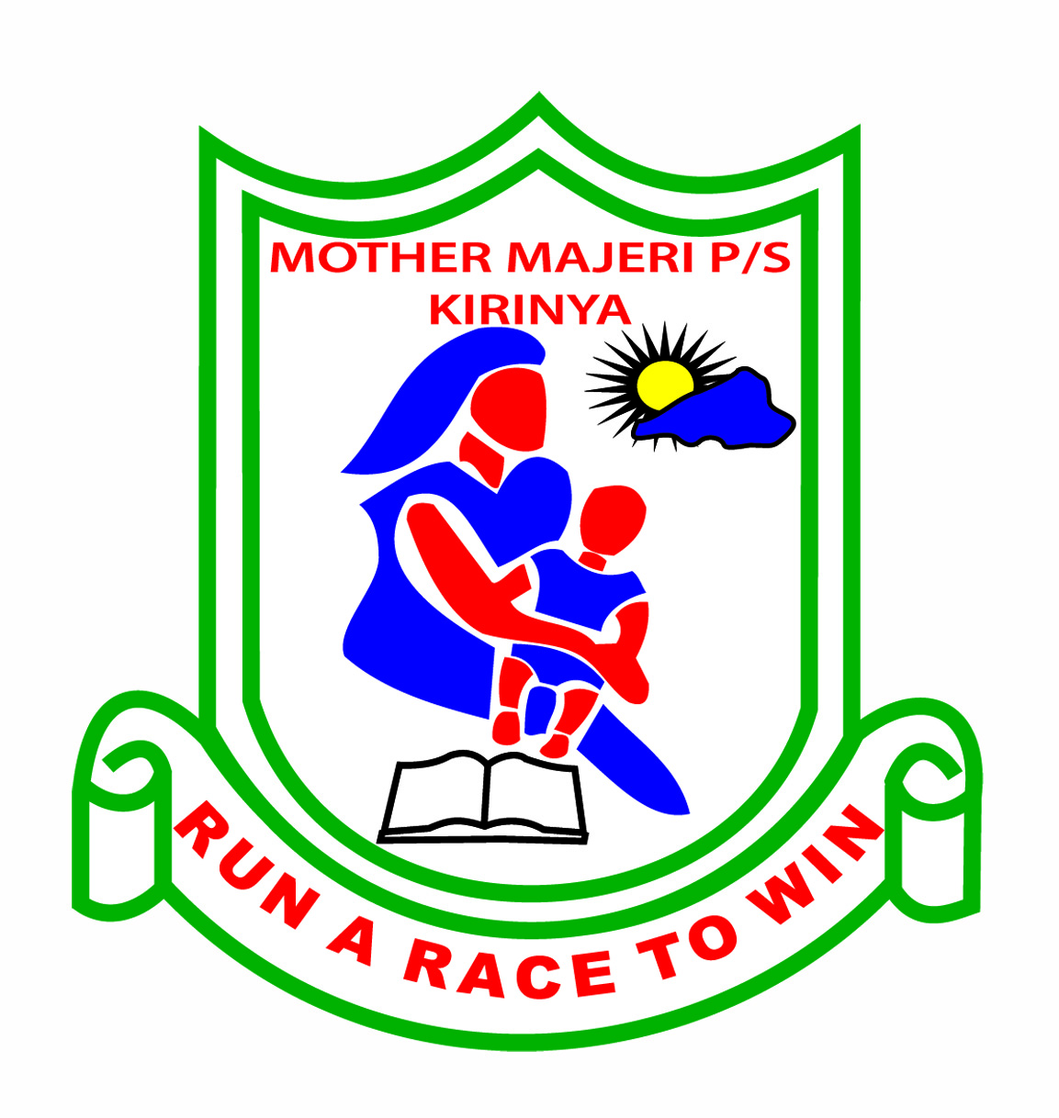**MOTHER MAJERI NURSERY SCHOOL**

**END OF TERM II EXAMINATION, 2024**

**CLASS : MIDDLE CLASS**

**AGE : 4-5 years**

**SUBJECT : General Knowledge**

**My name is :________________________________stream:_______**

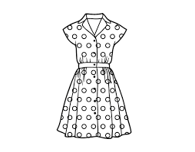**1. Name the pictures.**

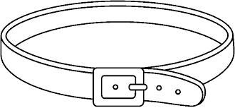

**_____________ _____________**

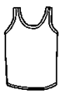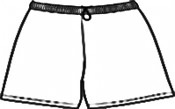

**_____________ _____________**

[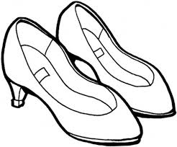](http://www.google.com/imgres?imgurl=http://www.clipartbest.com/cliparts/9cR/Rko/9cRRkoz9i.gif&imgrefurl=http://www.clipartbest.com/clipart-9cRRkoz9i&h=415&w=500&tbnid=hKt8NbPU4XarPM:&zoom=1&docid=8zbZS-K7Ic7oCM&hl=en&ei=qQ9LVeiKCMuuUf-dgagO&tbm=isch&ved=0CFsQMyhTMFM49AM)

**_______________**

short shoes belt vest dress

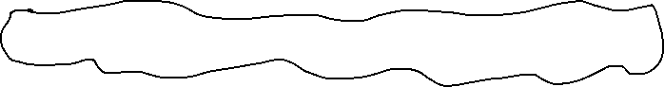

**2. Write the missing letters.**

[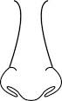](https://www.google.com/url?q=http://www.clker.com/clipart-totetude-nose-outline-2.html&sa=U&ei=8NjgU9nUJIew0QW7roGoCA&ved=0CCAQ9QEwBDg8&usg=AFQjCNHyiSfLRpze5cV1wvfScPTnuuZafw)**[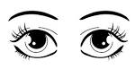](http://www.google.com/imgres?imgurl=http://hasloo.com/freecliparts/wp-content/uploads/2012/07/eyes.jpg&imgrefurl=http://hasloo.com/freecliparts/?p=2942&usg=__WeSygu9uwh1QPTQO5u9zl2JLxEc=&h=1155&w=2000&sz=349&hl=en&start=3&zoom=1&tbnid=QwA5FBbbsffcOM:&tbnh=87&tbnw=150&ei=H0gwUeKzL4iZ0QX-x4HoCg&prev=/search?q=eyes&hl=en&sa=X&gbv=2&tbs=itp:clipart&tbm=isch&itbs=1&sa=X&ved=0CDAQrQMwAg)**

e__es no__e

**[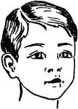](https://www.google.com/url?q=http://etc.usf.edu/clipart/63300/63366/63366_head.htm&sa=U&ei=zTo5U_24OoGHtQas04CYCg&ved=0CFYQ9QEwEzgU&usg=AFQjCNHm-NZ4-S8AlnarxFUNX7V2dV_v_w)**

[http://t1.gstatic.com/images?q=tbn:ANd9GcQ4liYMk31lDL6o-zRd5BprFXJ8SVNNKHpDIqOYOC4IAtz1ePlR9vyOedQ](http://www.google.com/imgres?imgurl=http://www.supercoloring.com/wp-content/main/2009_07/lips-coloring-page.jpg&imgrefurl=http://www.supercoloring.com/pages/lips/&usg=__K9U4QdCJtmMaGFvnGc8bBUnwS5w=&h=153&w=465&sz=20&hl=en&start=12&zoom=1&tbnid=eH0hFT1GdF4RcM:&tbnh=42&tbnw=128&ei=s0gwUYGpDaTD0QWs_YGwCQ&prev=/search?q=mouth&hl=en&sa=X&gbv=2&tbs=itp:lineart&tbm=isch&itbs=1&sa=X&ved=0CEIQrQMwCw) mouth __ead

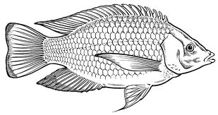**3. Tick the correct word for the picture.**

home fish

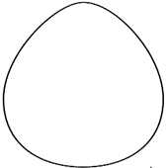

eggs banana

[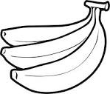](http://www.google.com/imgres?imgurl=http://www.newcoloring.net/wp-content/uploads/2013/05/banana-fruit-pictures-coloring-pages-for-kids-boys-girls-17.gif&imgrefurl=http://www.newcoloring.net/4657/banana-fruits-coloring-pages-free/&usg=__8cpaHwu5eOLB6ACLl_xYmd6Idg8=&h=826&w=972&sz=22&hl=en&start=12&zoom=1&tbnid=rUydnPEcsA9wwM:&tbnh=127&tbnw=149&ei=RdzsUbPXLYTYsga-jYDgAw&prev=/search?q=bananas&sa=X&hl=en&sout=1&biw=1341&bih=555&site=imghp&tbs=itp:lineart&tbm=isch&itbs=1&sa=X&ved=0CEQQrQMwCw)

bananas yam

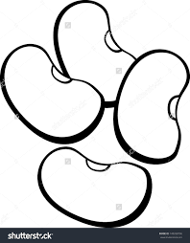

bed beans

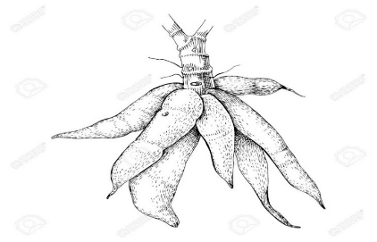

cassava cat

**4. Match the word for the picture.**

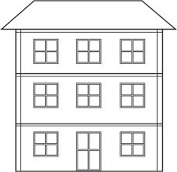

bungalow

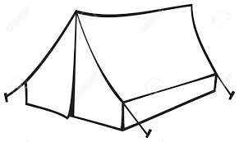

hut

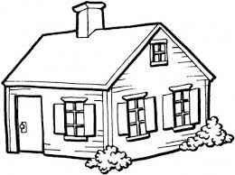flat

tent

**5. Underline the word for the picture.**

church hat

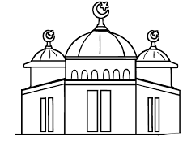

duck mosque

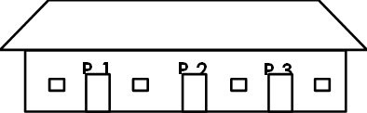

school bag

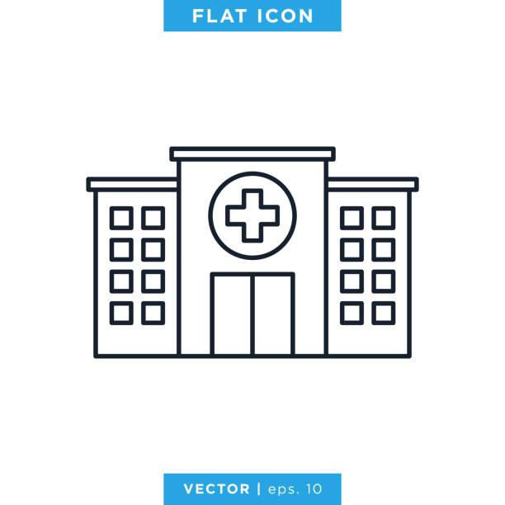

pin hospital

**6. Circle the same word.**

pin pin mat

cat doll cat

book book bed

moon man moon

banana knife knife

chair chair broom

**7. Read and draw.**

mother dog

mango broken bottle

hen church

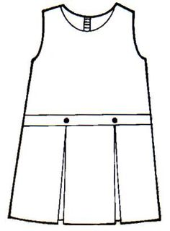**8. Shade the things we wear.**

dress

[](http://www.google.com/imgres?imgurl=http://www.clipartbest.com/cliparts/9cR/Rko/9cRRkoz9i.gif&imgrefurl=http://www.clipartbest.com/clipart-9cRRkoz9i&h=415&w=500&tbnid=hKt8NbPU4XarPM:&zoom=1&docid=8zbZS-K7Ic7oCM&hl=en&ei=qQ9LVeiKCMuuUf-dgagO&tbm=isch&ved=0CFsQMyhTMFM49AM) Shoes

**END**